**EE 185**

Homework Rubric

horizontal line

Homeworks should be a reflection of your learning and development. They should show careful thought and demonstrate methods learned in class. Rubrics for homework will change throughout the semester to reflect how things like organization should become second nature. Homeworks will be graded on the following scale:

|  |  |  |
| --- | --- | --- |
| **Category** | **Student Score** | **Grader Score** |
| **Organization** | | |
| **Basics** | **1/1** | **/1** |
| **Structure** | **2/2** | **/2** |
| **References** | **1/1** | **/1** |
| **Work** | | |
| **Effort** | **2/2** | **/2** |
| **Clarity** | **2/2** | **/2** |
| **Discussion** | **2/2** | **/2** |
|  |  |  |
| **Total** | **10/10** | **/10** |

**Problem 1:**

Read the article carefully.

a. Write a summary of what the article is about.

The moral dilemmas that come with driverless cars and how the debate although interesting should not be the only concern when it comes to driverless cars.

b. Write an itemized list identifying information that you found interesting and noteworthy to keep.

That morality of driverless car

The economic factors behind buying a car that wouldn’t prioritize your safety

The security aspect of being able to remoting control somebody else's car

c. What did you find to be the most interesting part of this article? And why.

I found it interesting that they brought up the

d. Can you explain how this car works to someone who is not technical? Try it in words. How?

It is a car that uses sensors such as cameras to detect potential hazards before a crash is imminent.

e. Are there any important Socio-Technical considerations that an engineer needs to think about?

It is important to remember that decisions made today will affect how other machines and set a precedent for future automation.

**Problem 2:**

1. Given the line Line 1: -4x+2y=5 a) Find the equation of a line that is parallel to this line and passes through (x=2, y= - 5) show your detailed work

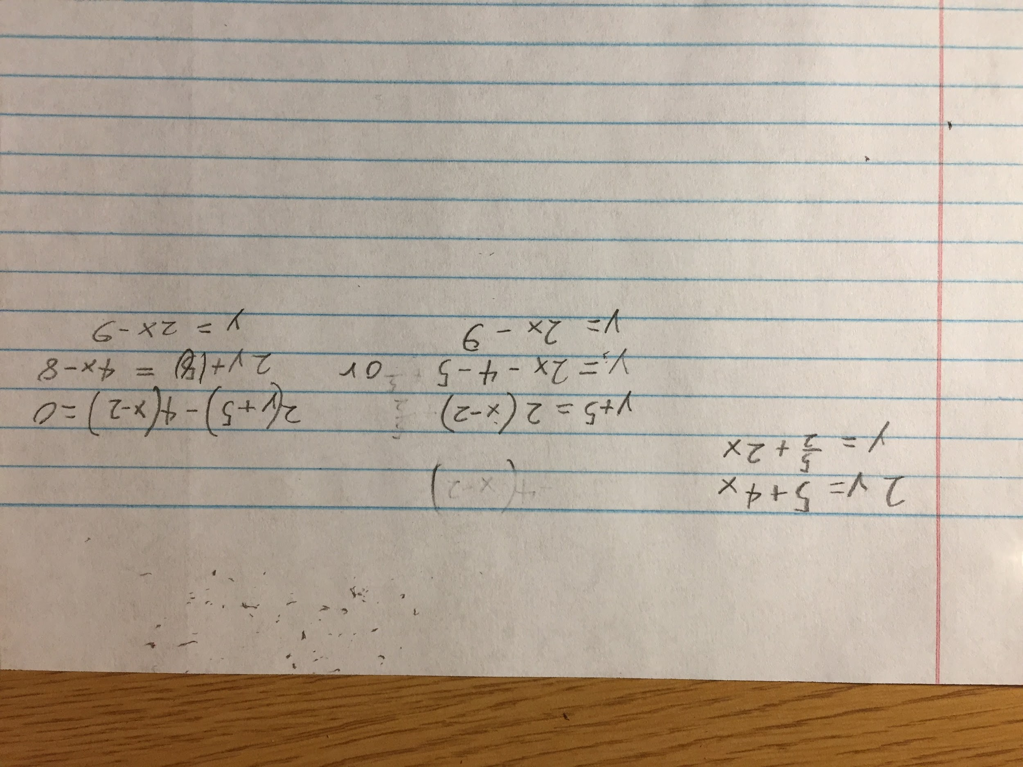

1. Would line 1 ever cross line 2: -4x+3y= - 5 explain and if they cross find the point that they cross

Yes the two lines would cross because they have different slopes so they are not parallel.

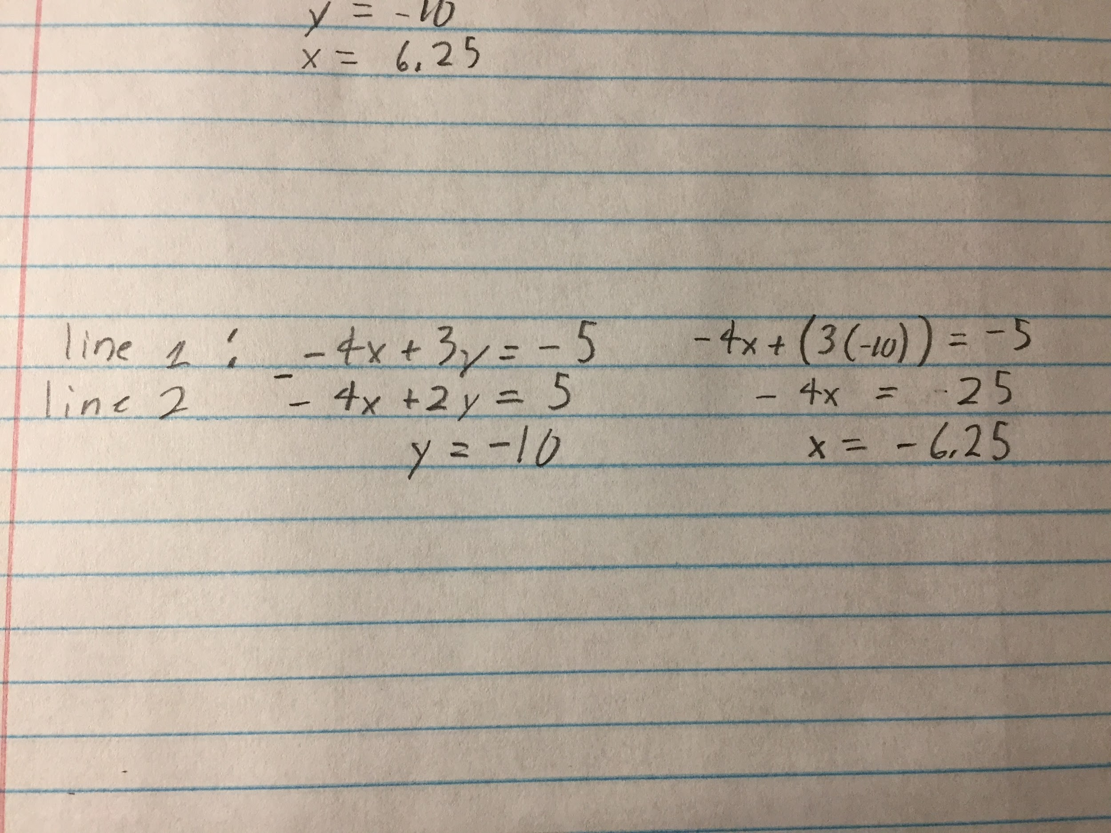

I subtracted the two lines because the -4x’s would cancel out leaving just 1 y. I then used the y to solve for x. This point exists on both lines and thus is where they intersect.

**Problem 3:**

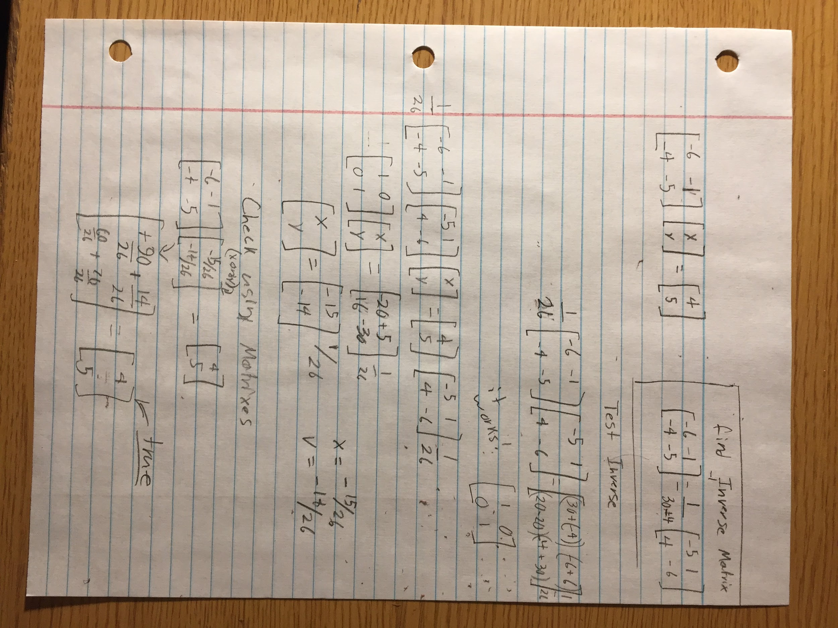

**Problem 4:**

**A simple guide to electronic components.**

a) what is it about?

Understanding a lot of the basic parts used in electrical engineering. This included resistors, capacitors, diodes, and transistors. After going over the parts he than talks about Ohm’s Law and goes through examples including diodes. He finished with the color codes for resistors.

b) What was interesting?

I found his explanations neat as well as his little tidbits such as how reading blue resistors is annoying. I also liked his drawing and his examples such as when he made a capacitor. He told stories of things that people know of such as the video game example. Also that he used a different electrolytic capacitor symbol then what I am used to. He also was not afraid to burn a resistor for the sake of science and demonstration.

c) What did you learn from the video?

Carbon film resistors are the beige colored ones whereas the metal film are blue. I have a bunch of blue resistors and now I know what type they most likely are. I didn’t know that capacitors came in so many different types, I had never seen a high voltage capacitor that wasn’t electrolytic. I also didn’t realize that electrolytic capacitors could dry out. I had no idea that old leds looked more similarly to normal LEDs.

d) Whom do you recommend it to? And why?

I would recommend this video to my friend so he could better understand what the parts do because he has experience with the parts but not much knowledge of how they’re used or how they work. I would probably need to clarify some things because he doesn’t explain everything that is involved with the parts.

**Transistors, How do they work ?**

a) what is it about?

About how transistors are used in all of our modern devices and how they work in many different ways.

b) What was interesting?

Their models were quite strange, they work as examples.

c) What did you learn from the video?

I didn’t really learn much from the video because the other video already talked about transistors and I knew about doping beforehand.

d) Whom do you recommend it to? And why?

I would recommend this video to the same person as before because he would appropriate the simple explanation.

**Using a Transistor as a Switch**

a) what is it about?

How to fashion a transistor as a switch and the math that comes with calculating the resistor required.

b) What was interesting?

I thought it was really interesting how much power he was able to use with just a simple push switch because of the transistor. It was a good example of what the numbers actually mean, a good way of adding perspective.

c) What did you learn from the video?

I refreshed my understanding of transistors, I originally learned from the book Practical Electronics for Inventors which stressed the importance of transistors functions.

d) Whom do you recommend it to? And why?

Again I would recommend this video to my friend so he could better understand how transistors are used.